The 18th Japanese Speech Contest for University Students

Individual Presentation Category
Application Form and Guidelines

Contents

1. Application Form Guidelines

2. Individual Presentation Category Application Form

3. Tutor Confirmation Form
Important Notice

Although we are planning on holding the Finals Day event in-person, if the situation with Covid-19 changes the event may be moved online. Thank you for your understanding.

4. Checklist for Applicants

This application form is only for those applying for the Individual Presentation Category. If you would like to apply for the Speech Category or Group Presentation Category, please download the relevant application form from
https://jpf.org.uk/whatson.php#1235 or
https://www.batj.org.uk/en/speechcontest.html

The 18th Japanese Speech Contest
for University Students

1. Individual Presentation Category Application Form Guidelines

Instructions:
- Please send your completed application form in Microsoft Word format (.doc or .docx) by e-mail to speechcontest@jpf.org.uk before 15:00 (GMT) on Monday 5th December 2022 with a carbon copy (CC) to your Japanese tutor (please inform your tutor that you will be doing so).
- Your tutor must then complete the Tutor Confirmation Form and return it to speechcontest@jpf.org.uk before 15:00 (GMT) on Wednesday 7th December 2022 in order for your application to be valid. Please inform your tutor in advance that you are planning on entering the contest, and that he/she will be asked to confirm your eligibility. Your application will only be accepted after your tutor has confirmed your eligibility.

Eligibility for the Individual Presentation Category:
The contest is open to undergraduate students who:
- Are studying a Japanese course aiming for the equivalent of JF standard B1 or B2 (https://jfstandard.jp/summaryen/ja/render.do) at a university in the UK or Ireland.
- Who have spent not more than 12 months in total in Japan.
- Candidates with Japanese parents are welcome to apply.
- Undergraduate students who are studying Japanese as a foreign language as a degree course and studied abroad in Japan for a full academic year are not eligible.
- Postgraduate students are not eligible.
- Please also note that 1st prize winners from past BATJ and Japan Foundation Japanese Speech Contest for University Students cannot enter the same category again. However, 2nd prize winners and runners-up from previous contests are welcome to apply again this year.
If you are still unsure which category you are eligible for, please contact speechcontest@jpf.org.uk, specifying the name of your degree course, Japanese course and university.
Schedule:
Deadline for applications: | Monday 5th December 2022 (Before 15:00 GMT)
Deadline for the tutor confirmation form: | Wednesday 7th December 2022 (Before 15:00 GMT)
Deadline to record/submit a video of your presentation: | Wednesday 11th January 2023  (Before 15:00 GMT)
You must submit the following two items. (Detailed instructions on how to submit these will be given after you apply).
- a digital video recording of you giving your presentation.
- the presentation itself, as a Microsoft PowerPoint file.
Notification of result: | Early February 2023
Successful applicants will be invited to give their presentations at the speech contest finals.
The contest committee will provide general feedback reflecting on all applicants’ video recordings that they have submitted as part of their application.
Speech Contest Finals: | Saturday 4th March 2023

Presentation Details:
- Presentations must be given in Japanese and last 6-8 minutes. If your presentation is not within this time limit, you may be disqualified during the screening process.
- You can use notes when recording a video of your presentation. However, the evaluation criteria include presentation skills, such as an eye contact and engagement with audience.
- There will be no questions after the presentation.
- The theme of the presentation should be an introduction to something from the U.K. or another country outside of Japan. It is fine to include Japan for comparative purposes or as a minor part of your presentation; however, the main focus of your presentation should be on something from a country outside of Japan. A theme on general social or contemporary issues are also not suitable for this category.
- Make sure that your speech has a clear message that conveys your opinion to the audience.

- The audience will include native speakers of Japanese and those learning Japanese as a foreign language. We recommend that you choose a theme (e.g. a particular region, event, custom, etc.) that will appeal to this audience.
- Please note that your final presentation must be made in Microsoft PowerPoint format. Other formats will not be accepted.
- When you submit the presentation video, please be aware that this is your final and completed version, which will be presented to the selection panel of judges.
- The video should contain the presentation of the presenter and the PowerPoint slides on the same screen.
- You may not include any sound, video clips or other moving images in your presentation.
- All images in your PowerPoint presentation must be referenced with their source (please refer to the next page), if they are not copyright free. The source must be full and correct – search engine URLs are not acceptable. The source can either be listed together with each image, or listed on a final slide at the end. You should also cite any other resources you have used for any other aspects of your presentation (e.g. quotations).

Important information regarding referencing:

- You must use APA Referencing citation style to reference ALL images and quotations used.
Please refer to the examples of reference slides from previous Finalists below:

Example of slide referencing information and quotation sources:
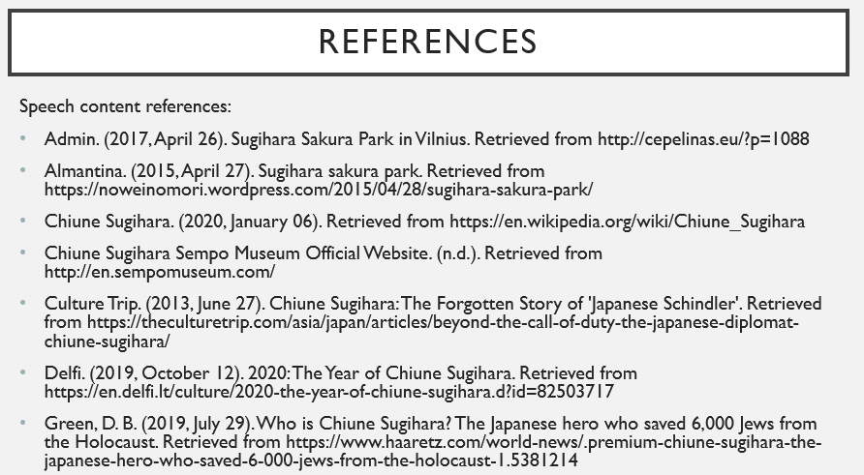

Example of slide referencing image sources:
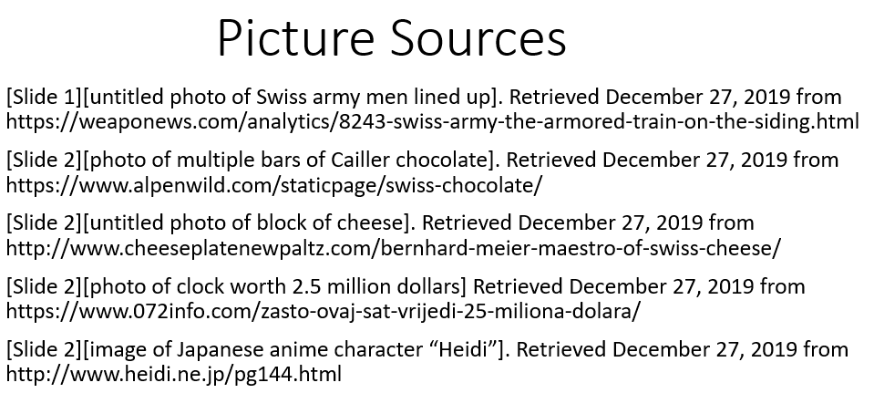

For more information on APA Referencing, please see the websites below:
http://libraryguides.vu.edu.au/apa-referencing/getting-started-in-apa-referencing
https://www.ukessays.com/referencing/apa/
http://www.bibme.org/citation-guide/apa/

If you have any questions, please contact speechcontest@jpf.org.uk

.
The 18th Japanese Speech Contest
for University Students

2. Individual Presentation Category Application Form
This application form is only for those applying for the Individual Presentation Category.
If you would like to apply for the Speech Category or the Group Presentation Category,
please download the relevant application form from https://www.jpf.org.uk/whatson.php?department=language or https://www.batj.org.uk/en/speechcontest.html

Title (Mr, Ms, etc.):
First name(s):
Surname:
First name(s) in katakana:
Surname in katakana:
First language:
Mobile number (including country code if outside the UK):
E-mail address:
Term-time address:
Name of University:
Name of Degree Course:
Year of degree course: |  | year
Name of Japanese course(s) enrolled on: |  | (e.g. Japanese 2A and 2B, Business Japanese 1, etc.)
Name of main Japanese course tutor:
Course tutor’s email:
Did you study Japanese before entering your current university? | Yes  No | If yes, where?  (Please state institution, location and dates)
 | Exam(s) passed:
Total time spent in Japan since the age of six: | years months
Presentation Theme: | In Japanese:  In English:  Please write the broad theme that you would like to make your presentation on. If you wish to make minor changes to this theme, please contact us before you submit your video and PowerPoint file by 15:00 (GMT) on 11th January 2023.

Please tick after reading our privacy notice (https://www.jpf.org.uk/download/Privacy%20Policy.pdf ):
I confirm that I have read the eligibility criteria and that I am qualified to enter the contest.
I confirm that my presentation will be my own work
I give my consent for any photographs or videos taken of me during the contest to be used by the Japan Foundation, BATJ and sponsors of the University Speech Contest for publicity purposes, including making photos/videos available to the public via the internet.

Name of Applicant: Date:

This form can be downloaded from https://jpf.org.uk/whatson.php#1235 or https://www.batj.org.uk/en/speechcontest.html
For all enquiries, please e-mail speechcontest@jpf.org.uk.

The 18th Japanese Speech Contest
for University Students

3. Tutor Confirmation Form
(To be completed and returned by the course tutor
named in the above application)

How to complete this form:

1. The applicant informs their main course tutor for Japanese that they intend to enter the 18th Japanese Speech Contest for University Students, and makes the tutor aware that they must complete this Tutor Confirmation Form to ensure the entry is accepted.

2. Applicants send this form to speechcontest@jpf.org.uk, and carbon copies (CCs) in the course tutor for Japanese named in the application

3. Course tutor reviews the details of the applicants that have referred them and ticks the confirmation below.

4. Course tutor returns the completed form by email to speechcontest@jpf.org.uk

Please note that this application will not be completed until we received this completed confirmation form by email directly from the course tutor referred to in the application.

To the Japanese course tutor of the applicant named in this document:
Please complete and return this form as soon as possible and by 15:00 (GMT) on
Wednesday 7th December 2022 to ensure that your student’s application is accepted.

First name:
Surname:
Position:
University:
Name of student:
Please tick after reading our privacy notice (https://www.jpf.org.uk/download/Privacy%20Policy.pdf ):
I confirm that I am the main Japanese tutor of the relevant applicant(s) named in this application.
I confirm that to the best of my knowledge, all details supplied by the above applicant(s) are correct.
I confirm that I have read the eligibility criteria, and that the applicant(s) named here meet the eligibility criteria for their chosen category to the best of my knowledge.
Date:

The 18th Japanese Speech Contest
for University Students

4. Checklist for Applicants
(for applicants’ own personal use)

During the application process, please double-check the following task checklist. Please tick off each task once it is complete. You can use this checklist to track the progress of your application.

You have checked your eligibility for the Individual Presentation Category.

All your contact details and university course details are correct.

You have included all details about previous visits to Japan.

You have returned the application form by email before 15:00 (GMT) to speechcontest@jpf.org.uk on Monday 5th December 2022. You have CCed in the main course tutor named in the application form.

All course tutors for all applicants in this category have been informed that you are applying for the contest, and that they are aware that they must submit a confirmation form in order to complete your application by 15:00 (GMT) on Wednesday 7th December 2022.

You have received a confirmation email from the Japan Foundation (speechcontest@jpf.org.uk) within 3 working days of sending your application (if you do not receive this email, please contact the Japan Foundation on speechcontest@jpf.org.uk

We encourage you to apply at least one week before the deadline to ensure that any potential problems with your application can be resolved before the deadline.

Good luck!

